| ***1. ReactJS-HOL*** |
| --- |

**Define SPA and its benefits**A Single Page Application (SPA) is a web application that loads a single HTML page and dynamically updates content without refreshing the entire page. It interacts with the user by rewriting the current page rather than loading entire new pages from a server. The key benefits of SPA include faster navigation, smoother user experience, reduced server load, and better performance after the initial load.

**Define React and its working** React is an open-source JavaScript library developed by Facebook for building user interfaces, especially SPAs. It allows developers to create reusable UI components that manage their own state. React works by using a virtual DOM and updating only the parts of the actual DOM that have changed, making it efficient and fast.

**The differences between SPA and MPA** SPA (Single Page Application) loads a single HTML file and updates the content dynamically, while MPA (Multi Page Application) loads a new page from the server every time a user navigates. SPAs are faster after the initial load and are ideal for dynamic interactions, whereas MPAs are better suited for traditional websites with multiple pages like blogs or e-commerce platforms.

**Explain Pros & Cons of Single-Page Application** SPAs offer a fluid user experience, faster interactions, and lower server bandwidth usage. They also support offline capabilities and are easier to convert into mobile apps. However, they can have longer initial load times, are harder to optimize for SEO, and might face browser compatibility or security concerns compared to traditional websites.

**Explain about React** React focuses on building UI components in a declarative way. It lets developers design simple views for each state in an application, and React efficiently updates and renders the right components when data changes. Its component-based architecture makes code easier to maintain, reuse, and test.

**Virtual DOM** The Virtual DOM is a lightweight JavaScript object that is a copy of the real DOM. React uses it to track changes in the UI. When a component's state changes, React first updates the virtual DOM, compares it with the previous version (using a process called "diffing"), and then updates only the necessary parts in the actual DOM. This approach boosts performance.

**Features of React** React offers several powerful features like JSX (a syntax extension for writing HTML in JavaScript), a component-based architecture, unidirectional data flow, virtual DOM for performance, and support for hooks and state management. It's also easy to integrate with other libraries or frameworks and has strong community support.

Open any directory where you want to make the project and run the following commands :

**sudo npm install -g create-react-app**

Ensure you have proper permissions to run the commands. Since I’m using Ubuntu I'll augment a “sudo” to the start of the command. This will ensure root access is enabled with full R/W permissions.

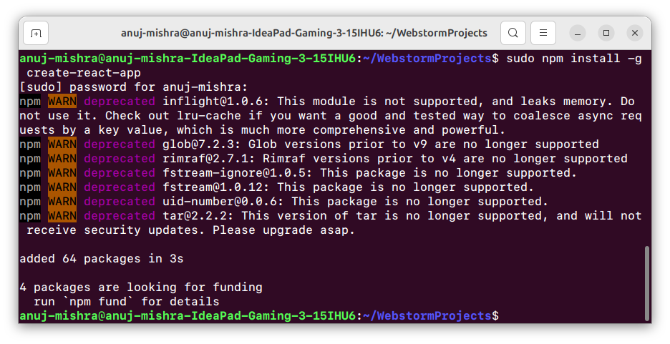

Then run :

**sudo npx create-react-app myfirstreact**

This will create a whole directory of react app project on the location with required dependencies.

Again ensure you have proper permissions to run the commands. Since I’m using Ubuntu I'll augment a “sudo” to the start of the command. This will ensure root access is enabled with full R/W permissions.

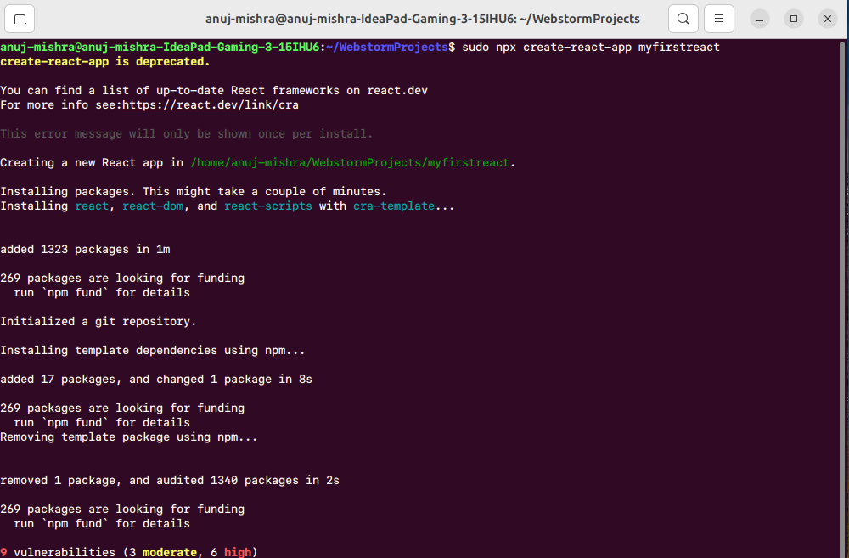

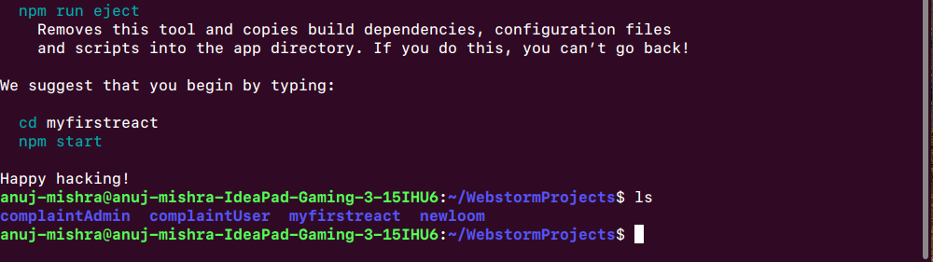

Optional : Before opening the app on the IDE, the user might not have appropriate permissions to R/W the folder contents. Run the following command suggested to ensure the same.

**sudo chown -R $USER:$USER ~/WebstormProjects/myfirstreact**

**chmod -R u+rw ~/WebstormProjects/myfirstreact**

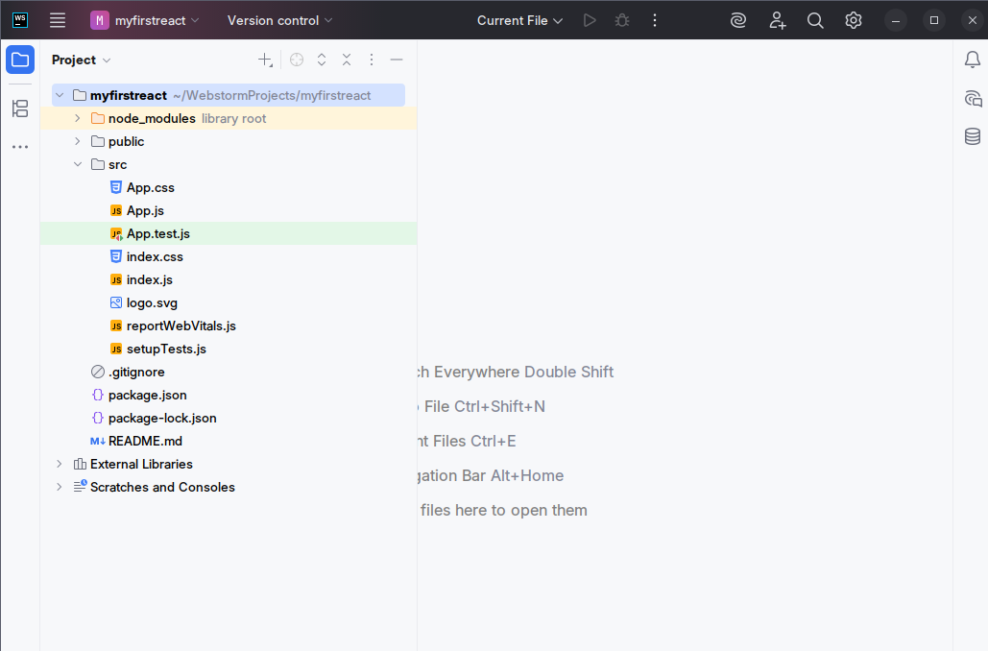

Replace the contents of [App.js](http://app.js) with the following :

function *App*(){

return (

<h1> Welcome to first session of React </h1>

);

}

export default *App*;

**function App() { ... }** This defines a functional component in React named App. In React, components are JavaScript functions or classes that return a piece of UI. Functional components like this are simpler and easier to manage compared to class components, especially when dealing with UI rendering only.

**return ( ... )** Inside the function, the return statement specifies what should be rendered on the screen. In React, the returned content must be wrapped in a single parent element — here, it's directly returning an <h1> tag.

**<h1> Welcome to first session of React </h1>** This is a JSX (JavaScript XML) element, which looks like HTML but works inside JavaScript. React uses JSX to define UI structure in a way that feels familiar to HTML. This line simply displays a heading saying "Welcome to first session of React" on the page.

**export default App;** This line exports the App component so it can be used in other parts of the project. Usually, this is imported into index.js (or main.jsx) where it is rendered into the DOM using ReactDOM.

Run the following command to launch the app by the following command :

**npm start**

And going to ->

**http://localhost:3000/**

